ù

Title: MPR and the economy
Subject: MTP 10

1. The Optimization problem  A. Components  B. Running the Optimization  C. Results and interpretation  D. Getting i*  2. PC-MPR System Plotting  A. MP from a negative equilibrium endogenous response  B. Effects of contractionary MP from efficient equilibrium, exogenous MP  C. Sudden inflatioary shock (ex. supply shock on v), endogenous response  D. Demand Shock, endogenous response  E. Other features | Previously we habe built equations to describe AS, AD and the CB preferences. Now we optimize the state of our economy considering the margin  al effects of the variables that the CB can change. We optimize the inflation/output gap trade-off  Solve a system of:  1. Phillips curve (Supply)  PC: $π= π^{e}+λx+ ν$, where λ = $\frac{(1-s)a}{s}$  2. IS curve(Demand)  $y={ y}^{e}-[r- ρ]$, *if flexible prices, in eq.: $y^{n}={ y}^{n, e}-[r^{n}- ρ]$ [2]  [1] – [2] + demand shock g: $x= x^{e}-\left[\left(i- π^{e}\right)- r^{n}\right]+g$  3. Monetary policy rule (MPR) (CB’s Loss function that models CB preferences)  L = $\frac{1}{2} [{\left(π- π^{*}\right)}^{2} + ω{\left({x- x}^{*}\right)}^{2}]$  x* > 0 if CB wants to target a positive gap, maybe to correct distortions due to mkt failure that are making y < y^{n}  CB chooses i to minimize L subject to PC and IS. We minimize L subject to PC and then fill the results in IS to deduce i  Assumptions  i. CB choses just i, and i affects AD, hence π and x. To simplify we assume CB choses directly π and x.  ii. Assume x* = 0 and that CB takes expectations of inflation $π^{e}$ as given (called “discretionary optimization” as the CB chooses MP after agents have formed their expectations). In our model CB actions under discretion, not under commitment (CB fixes future expectations and commits). No commitment = no influence on future expectations. Optimization just regards current period outcome.  Optimization process  PC into L by x: L = $\frac{1}{2} [{\left(π- π^{*}\right)}^{2} + ω{\left(\frac{π- π^{e}+v}{λ}\right)}^{2}]$ , we call ${f= π}^{e}+v$  maximize (FOC) wrt π: $[\left(π- π^{*}\right) + ω\left(\frac{π-f}{λ}\right)\frac{1}{λ}]$ since from PC $\frac{π-f}{λ}=x$ $\left( π- π^{*}\right) + ω\left( \frac{x}{λ} \right)$  Results and Considerations  $π- π^{*}=- ω\left( \frac{x}{λ} \right)$ is called the MPR (monetary policy rule) curve (optimal monetary policy)  MB  MC  MC of inflation: dL/dπ = $π- π^{*}$  MB of inflation: in PC if $π$+1u, +1/λ u of output gap is generated, now, since the MC of output gap is dL/dx = ωx the MC of higher $π$ in terms of higher output hap is 1/λ (ωx). Hence -1/λ (ωx)  Rewrite  δ = $\frac{ω}{λ}$ $π- π^{*}$ = - δx  if left term is positive MPR wants right term (output gap, Y_{CURRENT} – Y_{LT}) to be set negative (‘leaning against the wind’)  *$δ$ is the sacrifice ratio: how costly it is to disinflate by reducing x  Interpreting the slope  ω: the higher ω, the higher δ, hence, the lower the optimal decrease in output. Idea: the higher ω the higher the more stabilizing the output gap is a priority for the CB, thus the smaller is the optimal change in x.  λ: the lower λ, the higher δ, hence the lower the optimal decrease in output. Idea: λ is the slope of the PC. The lower λ the higher is the amount of output that must be sacrificed to reduce inflation, thus the smaller is the optimal change in x. Low λ: many sticky firms, these firms are slow in adjusting prices, if inflation goes down Demand plummets, hence output.  Substitute MPR into IS you get i*. The policy rule calls for increasing the nominal interest rate more than one-for-one whenever expected inflation rises above the target. This rule ensures that a rise in expected inflation leads the central bank to boost the nominal interest rate enough to raise the real rate of interest, thereby contracting the real economy. In addition, the nominal rate is fully adjusted for any changes in the central bank’s estimate of r*, the long-run equilibrium real interest rate. The nominal rate is also raised in response to a positive inflation shock.  Basic, this is a SR Equilibrium  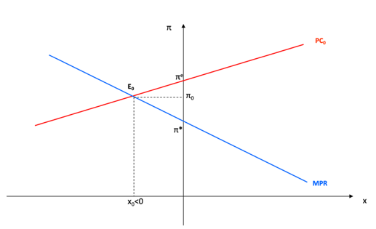  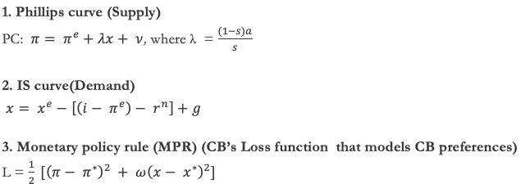  System of equations, you obtain π* and x*, where x* = $\frac{π + π^{e}}{δ+ λ}$ F. Fill PC with MPR to get x*  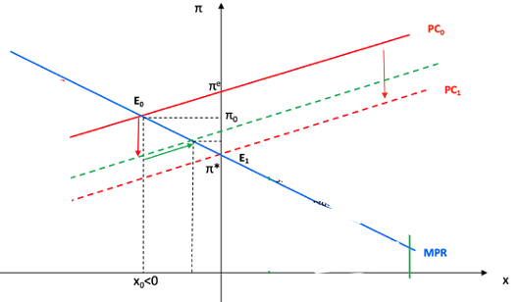  SR  In this example: x < 0. Ηence expected π is currently higher than target inflation, and current inflation is in between (Sticky firms are stuck at higher than optimal prices). CB is currently dealing with a positive inflation gap, hence accepts a negative output gap (already optimized its position using MPR finding best i*).  This equilibrium is consistent with both:  1. PC: $π= π^{e}+λx+ ν$, inflation lower than expected, output lower than optimal  2. MPR: $π- π^{*}$ = - δx, inflation higher than target, respond with negative output gap  LR  Sticky firms review expectations ( and adjust prices):  1. PC shifts down: now we have lower inflation level for the same output gap (Vertical movement)  2. x0 is no longer optimal, CB sets a lower negative x (expansionary monetary policy) --> Movement along the PC:  Inflation converges to the desired level. This basically corresponds to the assumption of rational expectations: actual and expected inflation cannot diverge for long, as agents observing systematically actual inflation different from expected will revise their expectations accordingly  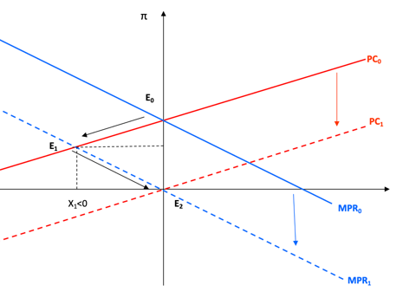  x = 0, π* = π^{n} = π^{e}  Imagine the new CB governor wants π* = 0  1. PC will not shift: Stocky firms are stuck at previous πe = π* > 0  2. MPR: $π- π^{*}$ = - δx need for negative output gap  then PC shifts progressively to equilibrium. In the final equilibrium E2, expectations are in line with the new target and the output gap is again zero  Basically CB has caused a recession.  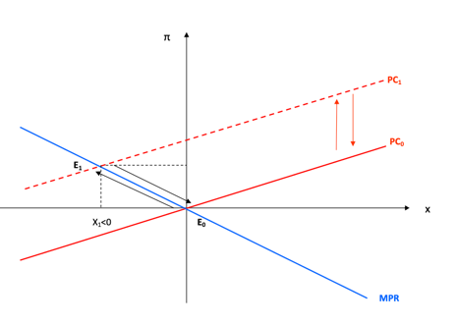  SR  1. PC shifts up, π1 >π*and x1 <0  2. The CB responds to the shock: it tries to limit the inflationary pressures through a reduction in the output gap. In presence of a supply shock the CB is unable to achieve the opt combination of inflation and output gap, given by π = π* and x = x* = 0. This happens even though expected inflation equals target inflation  LR  Targeted inflation stays fixed. Thus expected inflation starts moving down shifting at the same time the PC curve gradually toward its initial position. CB reduces progressively contractionary measures. To sum up, an increase in exp inflation determines, with inflation targeting, a temporary phase of negative output gap.  Key: inflation shock is considered to be temporary (does not affect expectations). If it lasts too much it may alter them, hence CB should anticipate this and intervene now!  The downward shift in the PC curve leads, in the short run, to a fall in inflation. Because this reduces the mar- ginal cost of inflation, the central bank acts to stimulate output, and the new short run equilibrium has a greater output gap (Figure 3).  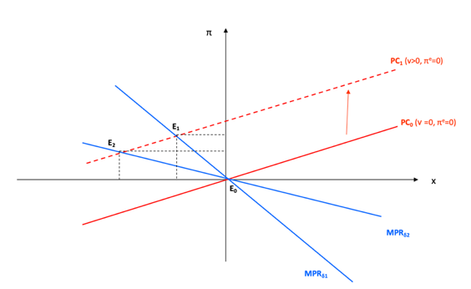  A positive demand shock shifts the MPR curve to the right. At each rate of inflation, the positive shock to demand increases the output gap. Because u represented unpredicted shifts in demand that the central bank could not offset, u shocks are strictly temporary in nature. On average, u equals 0, and the MPR curve returns to its original position. The economy returns to E0.  1. The CB credibility can influence on the convergence process. The more credible is the inflation target π* = 0 the more rapid will the convergence be.  2. Compare δ1 > δ2 in case of inflation shock  δ1 relatively less conservative CB  δ2 relatively more conservative CB  Qualitatively the two equilibria are the same. Eq. 1 tolerates higher inflation, bc wants higher output gap

